

**LAB 1**

**SEMESTER : 1 - 2017/2018**

**COURSE CODE : MANB1143**

**COURSE : BUSINESS INTELLIGENCE**

**PROGRAMME : MSc (BIA)**

**SUBMISSION DATE : 23 DECEMBER 2017**

**PREPARED BY : 1. AMJAD ALASSEH MAN171009**

**2. MUHAMMAD NIDZAM BIN MASO’OD MAN171043**

**SUBMITTED TO : DR AZIZUL AZIZAN**

ANALYSIS OF MALAYSIA EXPORT DATA TO US (2002~2016)

Contents

Introduction 3

Objective 3

Scope 3

Aim 4

Step of processing 5

1. Getting the data 5

2. Data pre processing 5

3. Data visualization 7

Result Finding 8

Summary 14

Reference 14

# Introduction

The United States is Malaysia's fourth largest trading partner and Malaysia is the 22nd largest trading partner of the US .Annual two-way trade in goods and services in 2013 amounted to approximately $44 billion. There are still a lot of trade opportunities for Malaysia’s companies to explore in United States. In order to devise a good strategic plan to explore the market in United States, we need to analyze what is the supply and demand are. We can do this by analyzing the trade data and getting insight on the demands and trends.

# Objective

The objectives of this report is

* To analyze Malaysia export data to United States from 2002~2016
* To design a dashboard using power BI from Microsoft that contains information of the data
* Using Power BI tools to analyze the trade data
* Gather insight from the trade data
* To develop a dashboard that has the ability to tabulate and visualize related data

# Scope

The scope of this report is the United States import data from Malaysia from the year 2002 to the year 2016.

Data is taken from below source,

<https://data.world/ita/trade-with-malaysia/workspace/file?filename=DATA_SITC_Total_All_Merchandise_Imports_from_Malaysia.csv>

This set of data was created by International Trade Administration (ITA).



Figure 1: ITA logo

# Aim

To produce an analysis that can assist the companies in Malaysia to develop a business plan and strategic collaboration to explore opportunities in US markets

# Step of processing

## Getting the data

For this report, we are using US import data from Malaysia from 2002 to 2016 from below source,

<https://data.world/ita/trade-with-malaysia/workspace/file?filename=DATA_SITC_Total_All_Merchandise_Imports_from_Malaysia.csv>

This data contain 16 columns and 250 rows

The 1st column contains the merchandise name and coding.

The 1st row contains the years value of the data.

## Data pre processing

Below are the steps taken to pre-process the data.

1. Data was imported to Power BI software.
2. In order to separate the item’s codes and item’s details below steps was followed
3. Use delimiter to separate item’s codes and item’s details

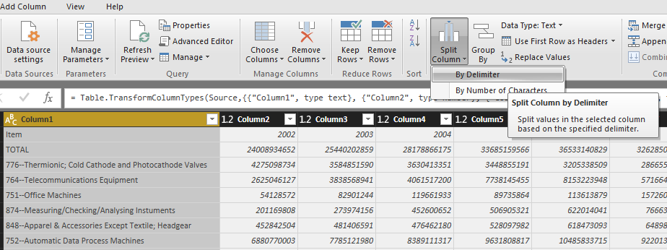

Figure 2

1. Remove unnecessary column and use the 1st row as headers, then remove the 1st row.Name the new created column as “Item details”

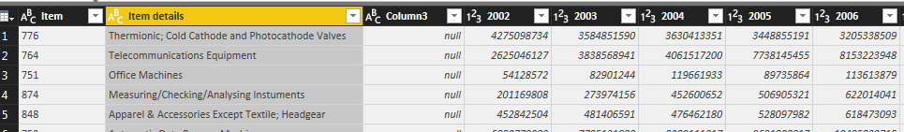

Figure 3

1. In order to do easier data analysis, the year value need to be in one column instead in row. For this, we need to un-pivot the data. Select the columns that we don’t want to un-pivot. Go to Transform tab->Unpivot->Unpivot Other Columns

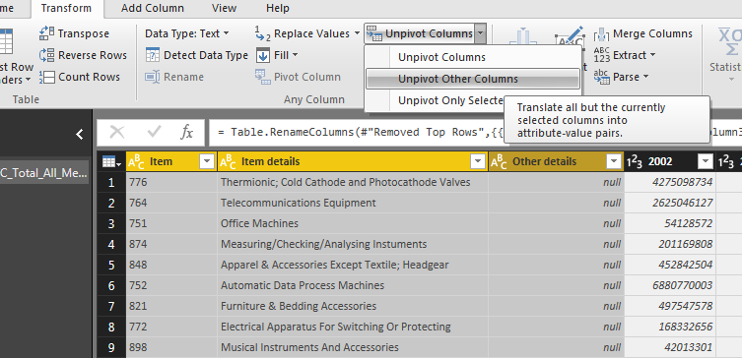

Figure 4

1. Rename the new created columns as “Year” and “Export Value [$]”
2. Click Clos & Apply tab to save the query. The data now ready for visual analysis.

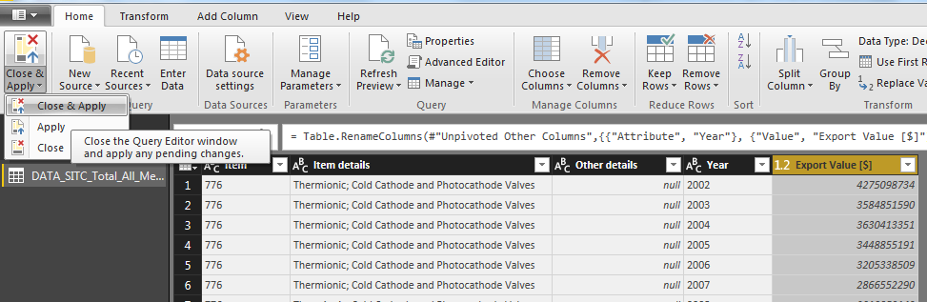

Figure 6

## Data visualization

Use data visualization tools in the Power BI to create a dashboard from the data.

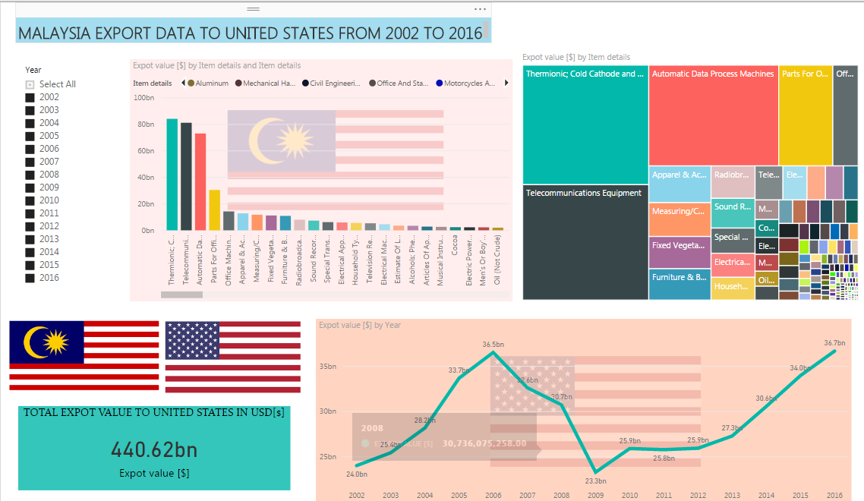

Figure 7: Dashboard in Power BI

# Result Finding

From the dashboard we can find out that the export to US from 2009 to 2016 is trending up. So export to US is in a very good shape.

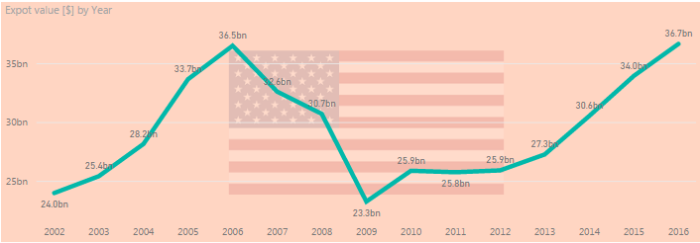

Figure 8: Overall merchandise export trend to US from 2002 to 2016

The top 3 export merchandises to US from 2002~2016 are

1. Thermionic; Cold Cathode and Photocathode Valves
2. Telecommunications Equipment
3. Automatic Data Process Machines

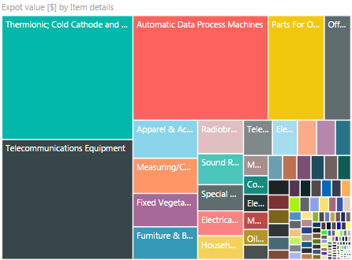

Figure 9: Treemap of overall merchandise export trend to US from 2002 to 2016

However this data can be misleading, as we drill down the trending for above 3 items,

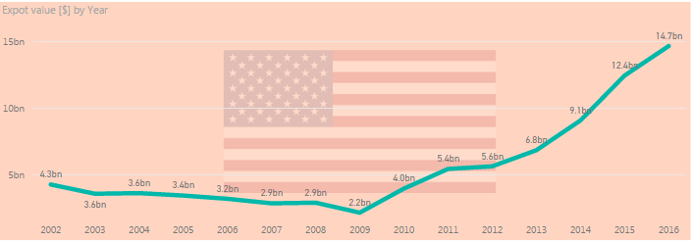

Figure 10: Thermionic; Cold Cathode and Photocathode Valves export trend to US from 2002 to 2016

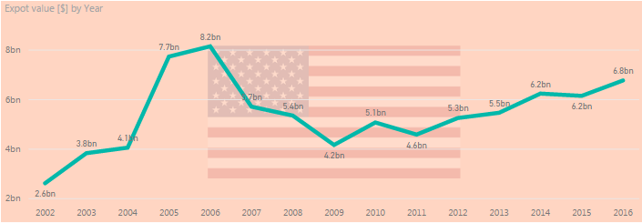

Figure 11: Telecommunications Equipment export trend to US from 2002 to 2016

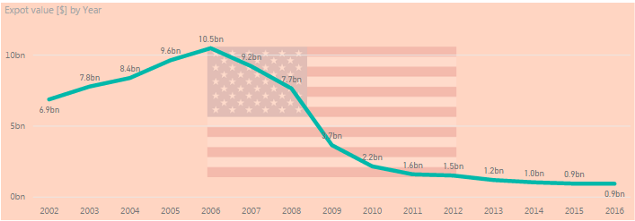

Figure 12: Automatic Data Process Machines export trend to US from 2002 to 2016

From these 3 figures, Thermionic; Cold Cathode and Photocathode Valves export are having an exponential increase while Telecommunication exports is having a steady increase. However for Automatic Data Process Machines export, although it has been the top 3 export for this last 14 years period, demand has become static and slowly decreasing over the year.

Thermionic; Cold Cathode and Photocathode Valves

Thermionic **cold cathode** or **photo-cathode valves** and tubes for example vacuum or vapour or gas filled **valves** and tubes mercury arc rectifying **valves** and tubes cathode-ray tubes television camera tubes



Figure 13: Cold Cathode used in neon lamp

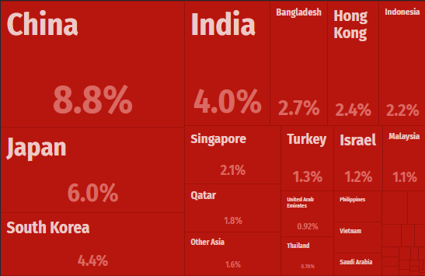

Figure 14:Treemap of Thermionic; Cold Cathode and Photocathode Valves world share. Malaysia shares is around 1.1%. Source <https://atlas.media.mit.edu/en/profile/hs02/8540/>

Other available opportunities

Others than the above mentioned merchandise, based on the analysis from the dashboard, merchandise producer can also focus on these below merchandise.

1. Measuring/Checking/Analysing Instuments

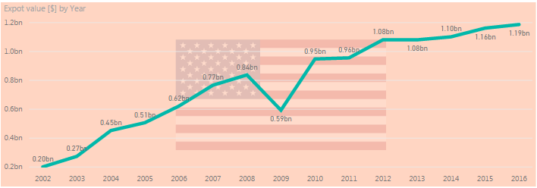

Figure 13: Measuring/Checking/Analysing Instuments export trend to US from 2002 to 2016

1. Musical Instruments And Accessories

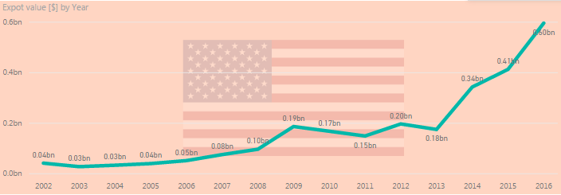

Figure 14: Musical Instruments And Accessories export trend to US from 2002 to 2016

1. Electrical Machinery And Apparatus

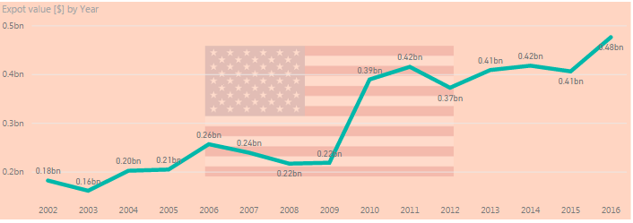

Figure 15: Electrical Machinery And Apparatus export trend to US from 2002 to 2016

1. Electric Power Machinery; And Parts

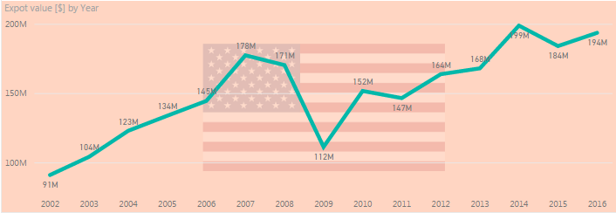

Figure 16: Electric Power Machinery; And Parts export trend to US from 2002 to 2016

# Summary

From the above analysis, we have identified the merchandises which is on demand now in the US market. By using this information, manufacturers and producers in Malaysia, can strategize on the products demand to make their entry in US market. By using the Power BI dashboard that we have created, we can also filter the demand and do the analysis by yearly basis.

By analyzing the data and harnessing the power of business intelligence, we can help our producer to compete with other countries. Without this insight, merchandise manufacturer and producer can avoid making the wrong decision thus propelling their businesses to further success in the future. The future of business handling and decision making in the future will lies in the business intelligence.

# Reference

<https://powerbi.microsoft.com/en-us/>

<https://docs.microsoft.com/en-us/power-bi/desktop-getting-started>

<https://data.world/>